**C.R.A.P.**

Contrast - Kevin Pinto

Repitition - Damian Guzman

Alignment - Gregory Rigot

Proximity - Khalid Ibrahim

[Digital Cover](https://digital-cover.com/)

[Animated Video Services: We Make Videos for Businesses – IdeaRocket (idearocketanimation.com)](https://idearocketanimation.com/)

**Contrast**

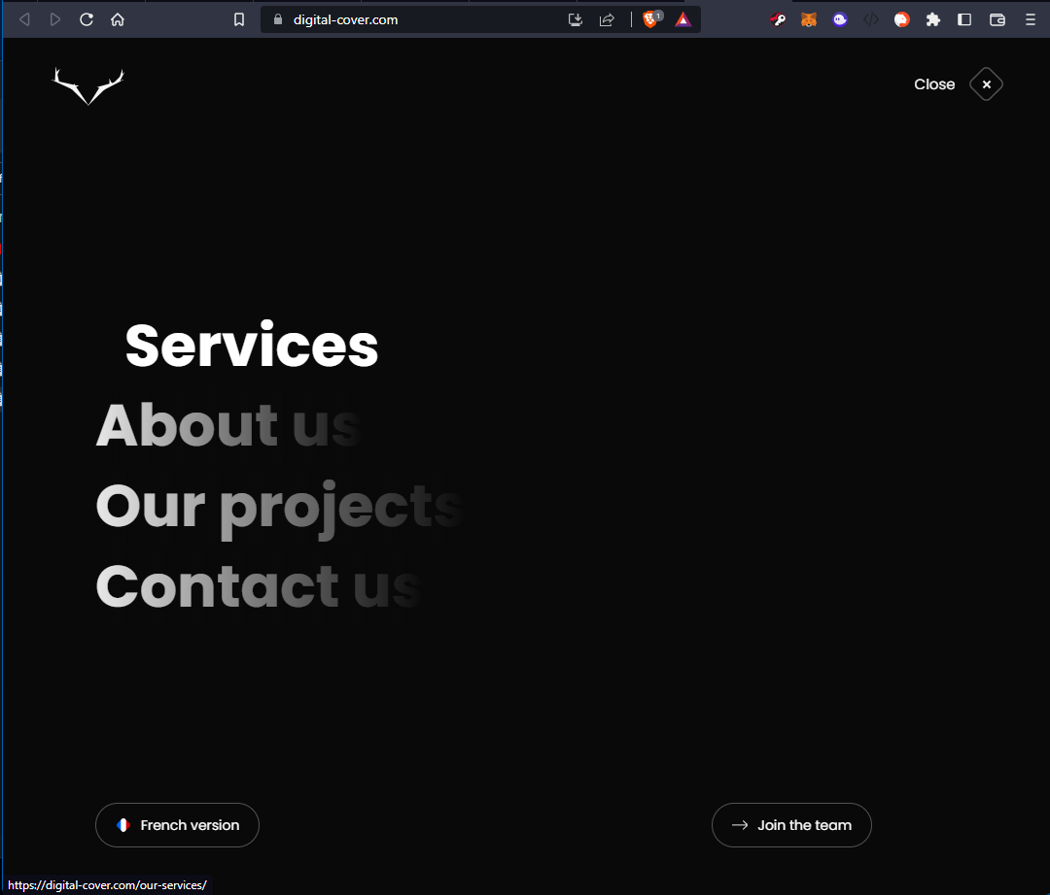

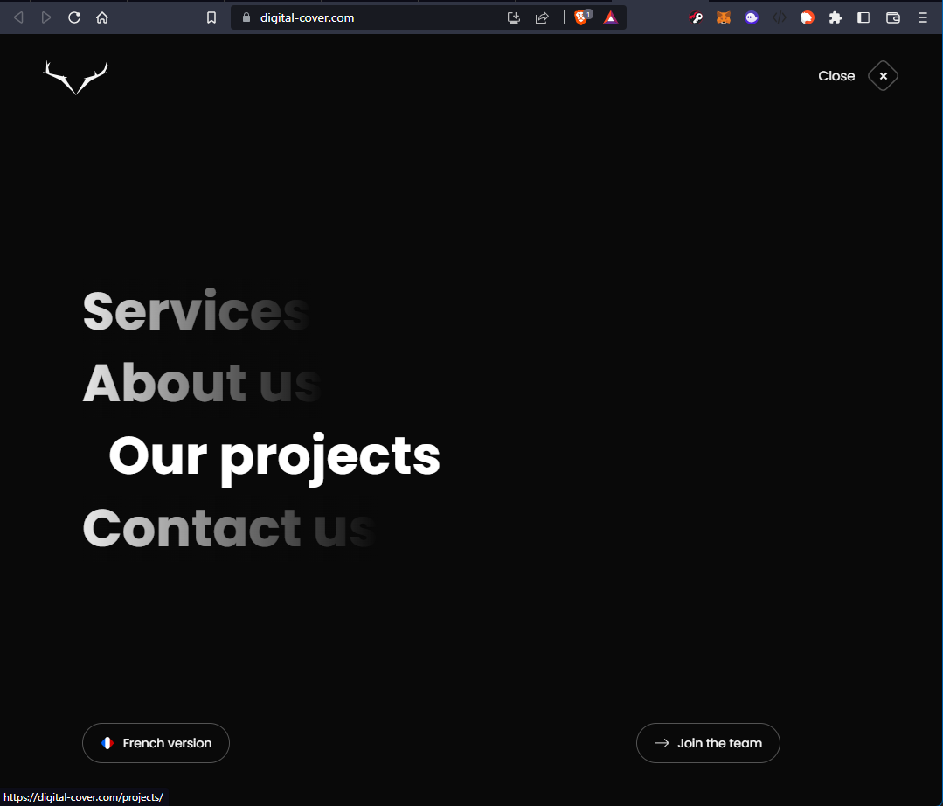

The Digital Cover website makes great use of Contrast with a simple white text on black backgrounds, and it’s consistent throughout the entire website. This contrast is further enhanced with the use of animations, like in the navigation menu. When the user hovers the mouse over one of the 4 different options, the website dims the other 3 options slightly making the option under the mouse pointer appear to stick out even more. The same white on black is used throughout the website.

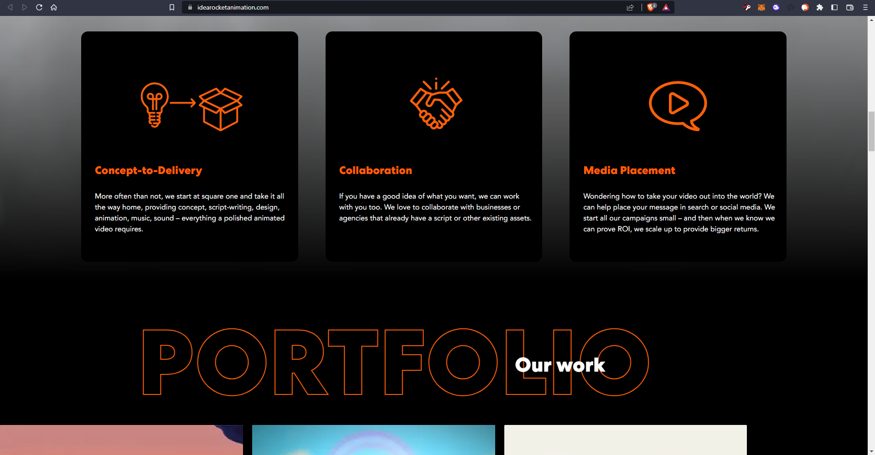

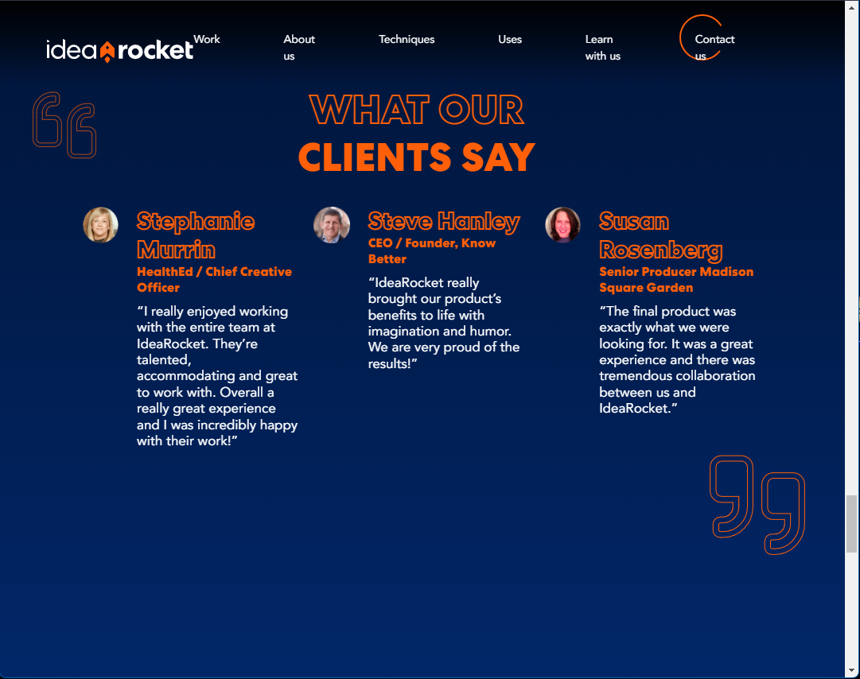

The Idea Rocket website also displays great use of contrast. Using a color gradient from the darker hues up top, to the lighter ones towards the bottom, the blue background makes the bright orange text pop and appear very sharp and defined. The background even appears to move from outer space, with stars on a completely black background, back down to the ground. The top navigation bar also has a black background with the opacity on a gradient, making the top part appear much darker and the bottom almost see-through, with consistent use of the whites and oranges.

**Repetition**

***Digital Cover (first website):***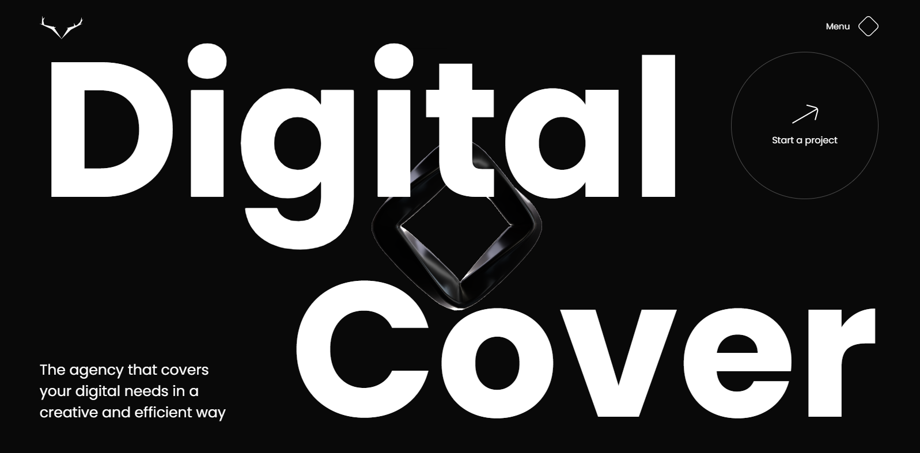

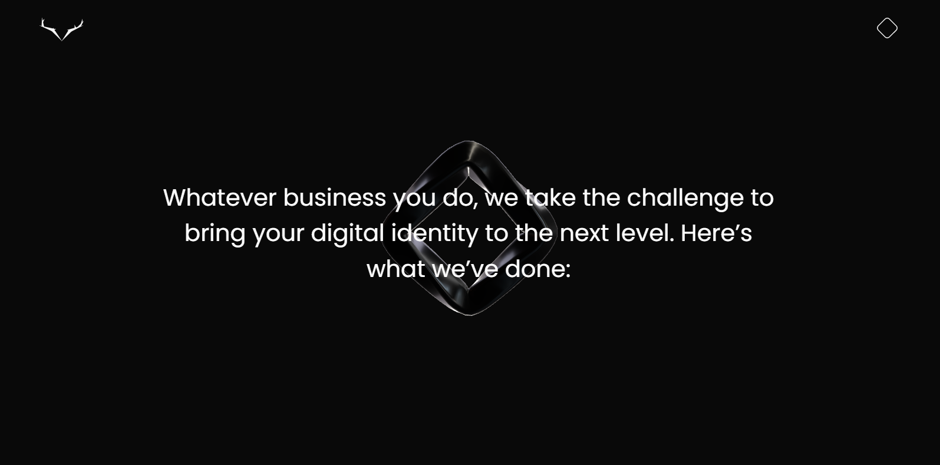

These three screenshots show repetition because the *Digital Cover* page is consistent with the black/gray background throughout. Also, the black diamond icon in the center in the first image can be taken as the company’s main logo which is also present throughout the page, and is always center aligned. Finally, the menu icon presented as a white-outlined diamond is present in the top right corner throughout the page.

***Idea Rocket (second website):***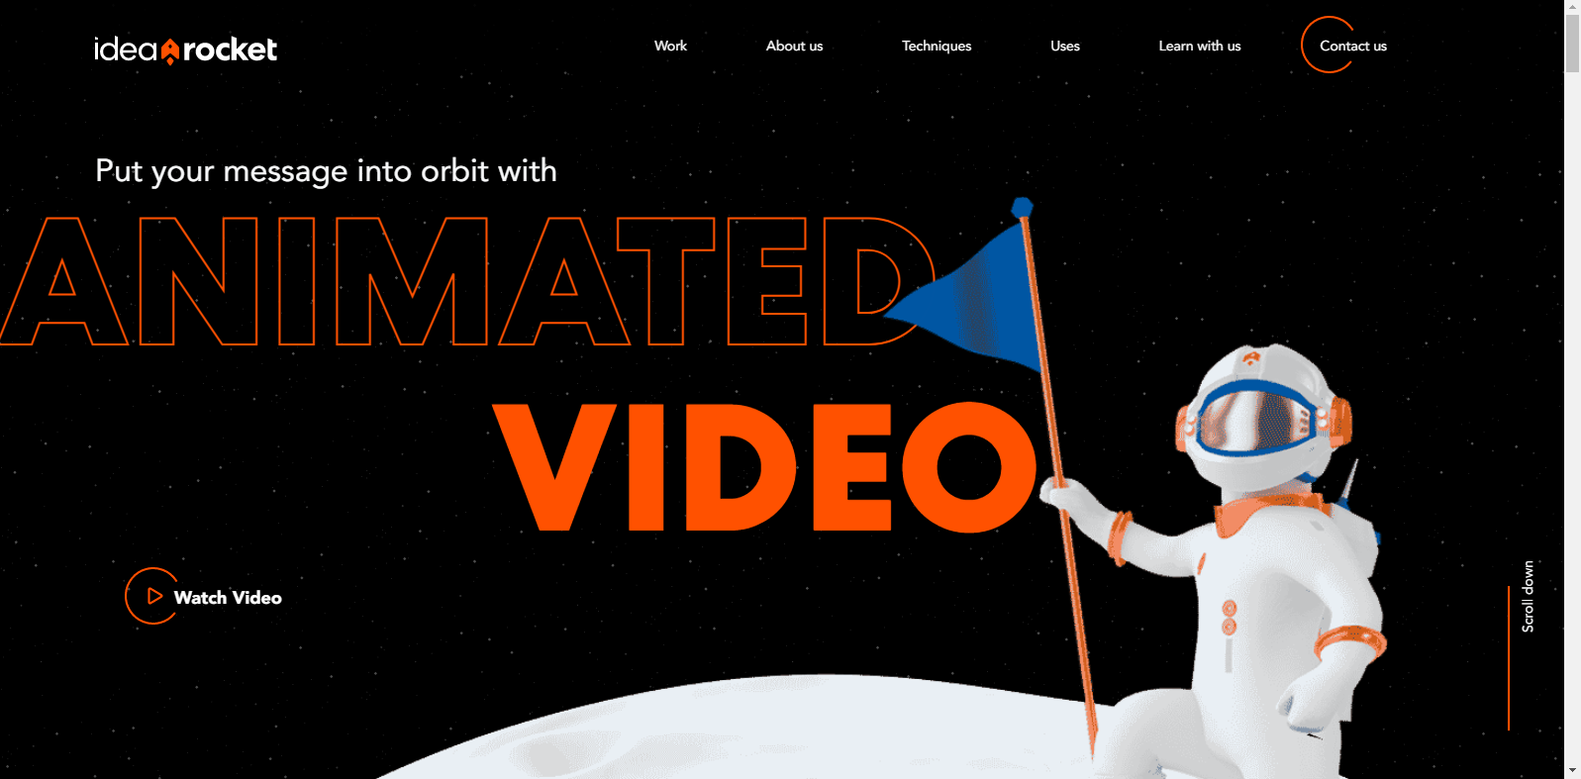

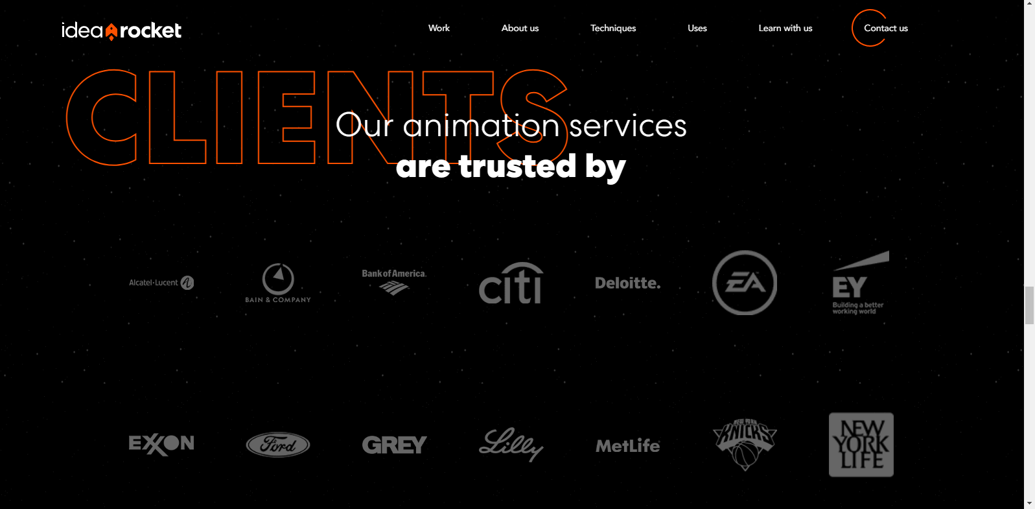

These three screenshots of *Idea Rocket* show repetition through the color scheme by including the orange highlighted lettering with the black background with gray and white for other text present. Also, the navigation bar is present throughout the page and becomes hidden if the user scrolls down but appears again when the user scrolls up.

Alignment





Digital Cover is a website that makes great use of Alignment, one of the four C.R.A.P design principles. The way Digital Cover utilizes this principle in its design given how it positions elements in ways to keep them organized and connecting elements with one another, which leads to cohesiveness in its designs. This is seen from the first image, in which it follows in a horizontal direction of how viewers may contact or find the people of Digital Cover. In the second image, the alignment is impacted by the incorporation of animation, in which each of the projects that had already been done by Digital Cover fade come from the background into the foreground while viewers scroll through the gallery, the central button serving as a link to whichever project is at the front and as a person scrolls through it all, the current project they are on and could look more into changes.





Idea Rocket is another website that conveys a great usage of alignment. With Idea Rocket, the use of alignment helps maintain the organization of the content of the website in addition to ensuring that the connections between each element of the website is evident. In the first screenshot, alignment is used to create a flow of some of the projects that Idea Rocket has animated and using the alternating positioning to make the projects stand out to viewers and encourage them to click on them to watch them. In the second screenshot, alignment is incorporated to keep the methods of how viewers can contact Idea Rocket or learn more about Idea Rocket grouped together in addition to a smaller version of the navigation bar at the top of the website’s webpage, listing the different links to other parts of the website that would explain more on what Idea Rocket is, what techniques are used in animating, how Idea Rocket has been used and even about Idea Rocket’s terms of usage and privacy policy.

Proximity

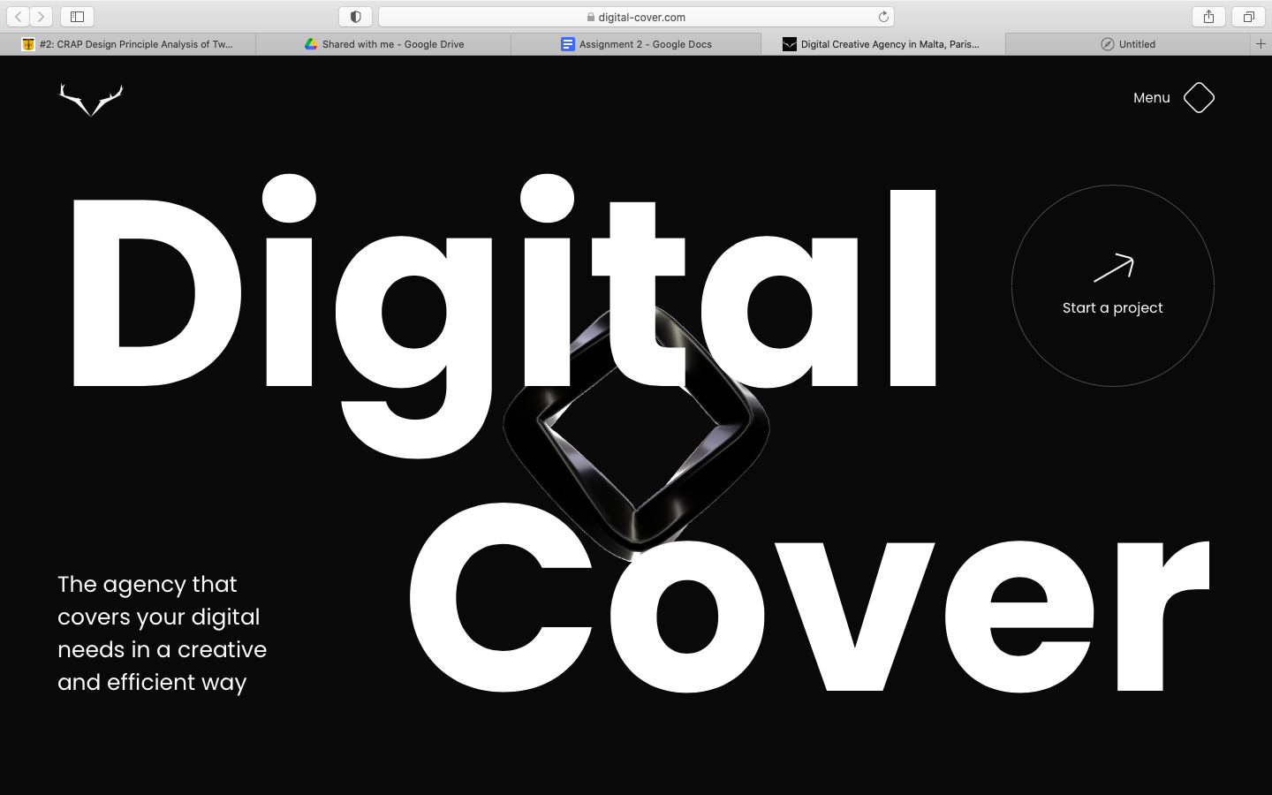

Digital cover is an agency that helps users design and manage highly interactive and digitally identifying websites for businesses. Here is a great example of one of the C.R.A.P design principles utilized to create an intriguing website design, proximity. Everything you need to know about Digital Cover and an easy way to get started is available on the cover in a well structured manner. They don’t stress the need to fill all the space on the frame evenly, but place information where it is easily readable. Each aspect of this part of the website is also amply spaced out to easily digest the info.

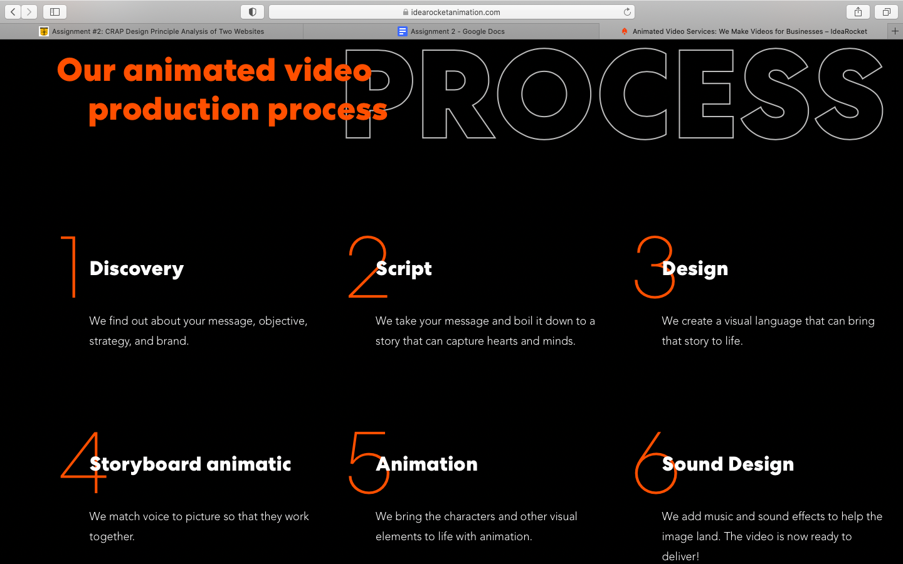

IdeaRocket is an animated video service provider for brands. They take your catchphrase or core message along with voice and give you a cartoon for your business. Here they utilize the C.R.A.P design principle,proximity, in their website and it proves well for the user experience. They condense the information that is needed to understand IdeaRocket into a frame closely so the reader can see all the important information in one place. There is also enough space between each numbered bullet point to allow for easy reading and decent spacing vertically as well.